

Kindergarten Helpers Needed

We are seeking students in **Grade 4-6** to take on the role of Kindergarten Helper. As a Kindergarten Helper, you

will assist with Kindergarten students in the classroom and outside in the Kindergarten play area.

The requirements for this position are listed below. The Learning Skills and Work Habits you will have the opportunity to build and demonstrate are shown in brackets followed by other words in *italics* that can be used to describe the same work habit.

For example, a coach or volunteer supervisor may have said you are *“Reliable”* and have good *“Teamwork”* skills. This is like saying you are “Responsible” and a good “Collaborator”. Knowing different words used to describe work habits can help you relate your school experiences to your experiences outside the classroom.

As a Kindergarten Helper, you will also have an opportunity to build and demonstrate your Essential Skills. These

skills are used in work, learning and life. Essential Skills are shown in **bold** after the work habits.

• Read the classroom rules and be prepared to explain them to students as needed. (Responsibility, *Reliability*,

**Reading Text, Oral Communication**)

• Arrive promptly to your assigned classroom or to the kindergarten play area (whichever was predetermined with the classroom teacher) at the very beginning of the nutrition break. (Responsibility, Organization, *Reliability*, **Scheduling or Budgeting and Accounting**)

• Actively assist and engage students in outdoor play activities. (Responsibility, Initiative, *Reliability, Working*

*Safely*)

• Be a good problem solver. For example, if a student is not listening or following the rules, talk to the student or get the supervising staff member to assist as needed. (Initiative, Responsibility, *Reliability, Self-advocacy*, **Oral Communication, Problem Solving**)

• In a positive manner, remind students to follow the rules and treat each other with respect. (Responsibility,

Initiative, *Reliability, Customer Service*, **Oral Communication**)

• Work collaboratively with your fellow Kindergarten Helpers and with Staff to discuss plans and issues.

(Collaboration, *Teamwork*, **Oral Communication**)

• When the bell rings to go inside, assist staff to “round up all students” and to put all supplies and equipment away. (Responsibility, Initiative, Collaboration, Organization, *Reliability, Teamwork*)

• When back inside, assist students to remove outdoor clothing and boots and wash their hands for nutrition break. (Responsibility, Collaboration, *Reliability, Working Safely*)

• Assist in the classroom by helping students to get their lunches from their backpacks and to open containers. (Responsibility, Initiative, Organization, *Reliability*)

• Remind students to follow the lunch room rules (posted in each classroom). (Responsibility, Initiative, *Reliability*,

**Oral Communication**)

• Assist students in cleaning up their lunches. (Initiative, Organization)

• Be a positive role model for all students in the class. (Self-Regulation, Responsibility, Initiative, *Reliability*)

• Return to your classroom promptly for the next period’s class. (Responsibility, *Reliability*)

Kindergarten Helper - page 2

• Talk with teacher to get feedback on interactions and job performance. (Initiative, Self-Regulation, Collaboration,

*Reliability, Teamwork*, **Oral Communication**)

• Schedule time to complete your tasks while taking into account your responsibilities in your other classes or extracurricular activities. (Organization, **Scheduling or Budgeting and Accounting**)

• Find a replacement Kindergarten Helper should you be unable to complete one of your shifts. (Responsibility,

Initiative, *Reliability*)

You can **transfer** your Essential Skills and work habits to everyday life or the next place you go – whether it’s

further education, training or the workplace. More information on how you use your Essential Skills and work habits in everyday life is on the Ontario Skills Passport website.

Identifying and reflecting on the Essential Skills and work habits you demonstrate as a Kindergarten Helper will help you develop your “All About Me” portfolio as you answer the four education and career/life planning inquiry questions: ***Who am I? What are my opportunities? Who do I want to become? What is my plan for achieving my goals?***

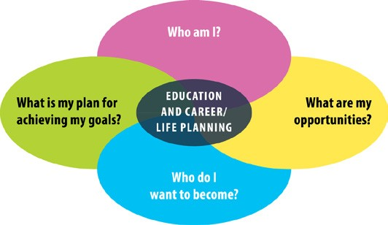

ontario.ca/skillspassport